Little Sirs Article for October, 2020 - Monthly Newsletter
2020…One reference to 2020 relates to vision. If you have 20/20 vision you can see clearly at a distance of 20 feet. However, I confess I don’t see anything clearly which is related to the year 2020. Almost everything from January to October 2020 is a blur. However, (in October, 2020) I have found a few things which are very clear. Since our last newsletter our mountain community in north eastern Fresno and Madera counties has been ravaged with fire and enveloped in daily smoke…some days it is thick and lingers all day.
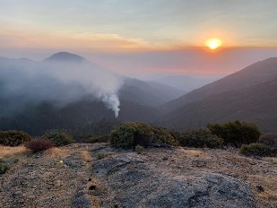 Creek Fire at Camp Sierra – Fri., Sept. 4 - about 4 pm. Picture taken from Helicopter pad at Big Creek.
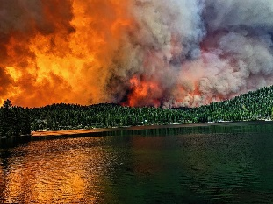 Creek Fire – Sat., Sept. 5 – about 10 am – west end of Huntington Lake at dams.
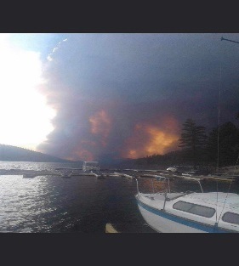 Creek Fire – Sat. Sept. 5 – about 12 noon – picture taken from Lake Shore marina looking west.
My thoughts for this article focused on “2020” – “Vision”…clarity and the uncertainties we have shared.
Scott Barcus, Little Sir-2020

