FEB 2025

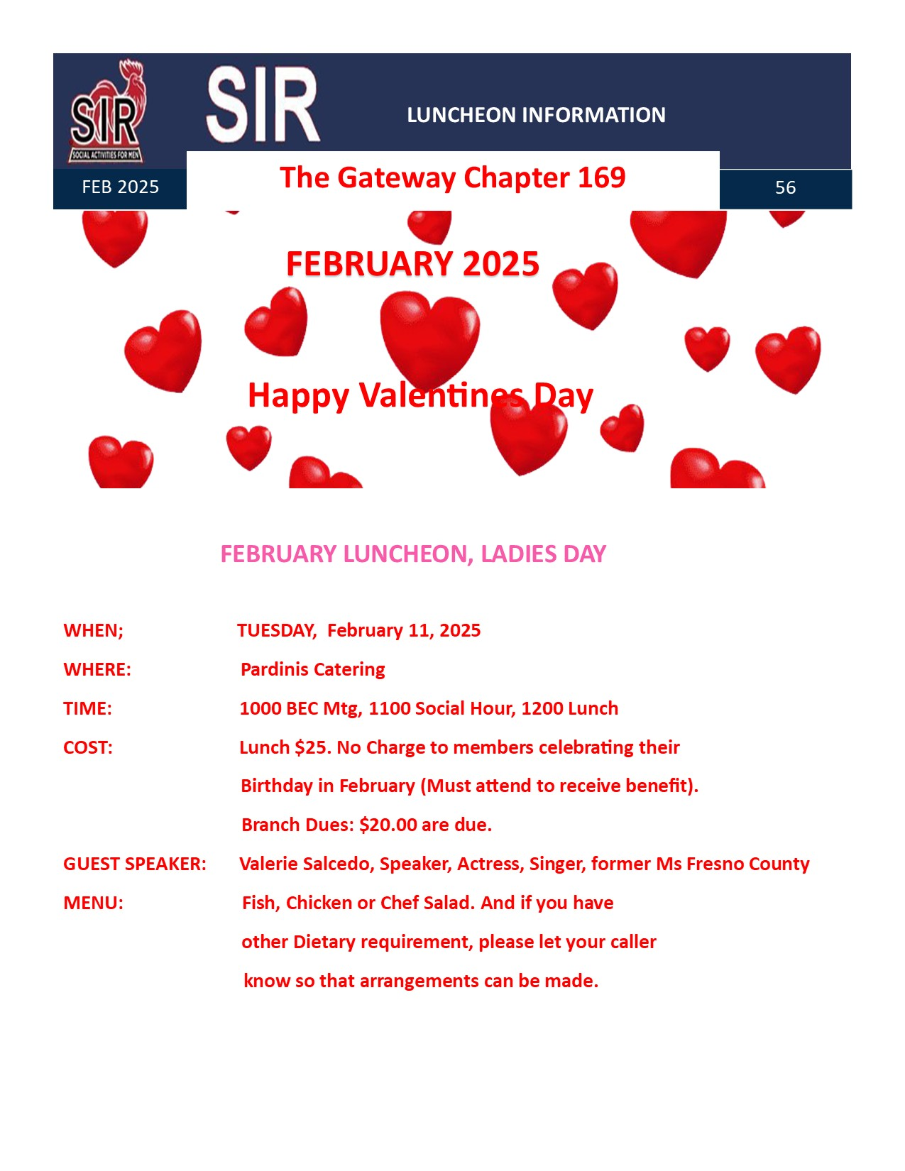

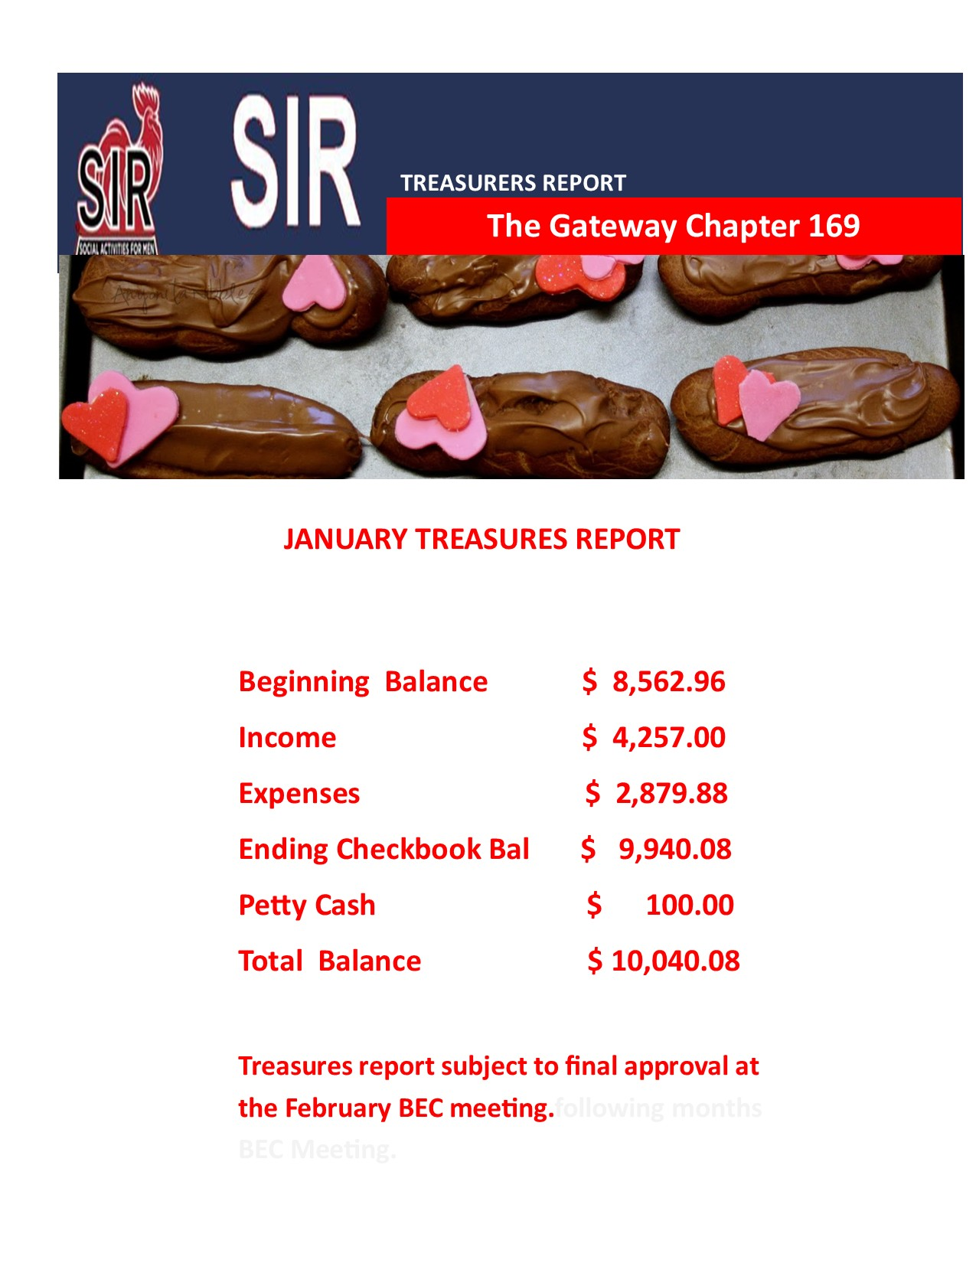

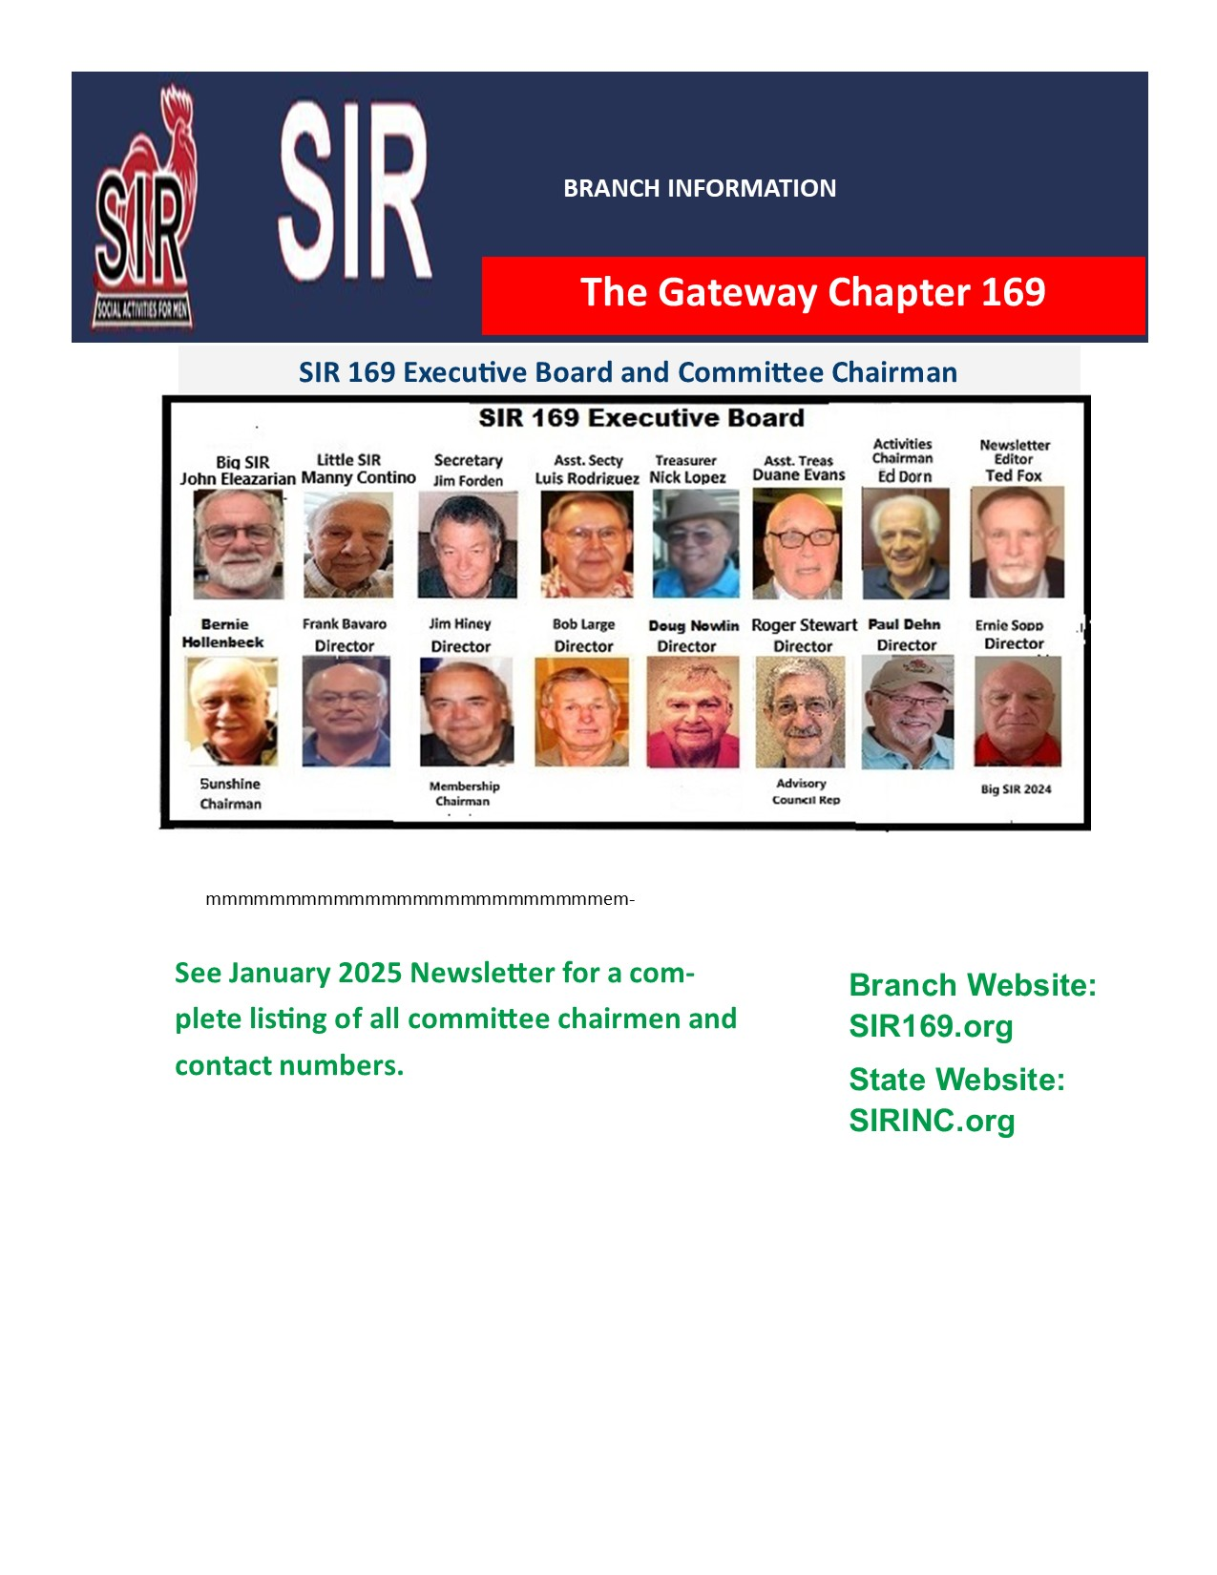
56

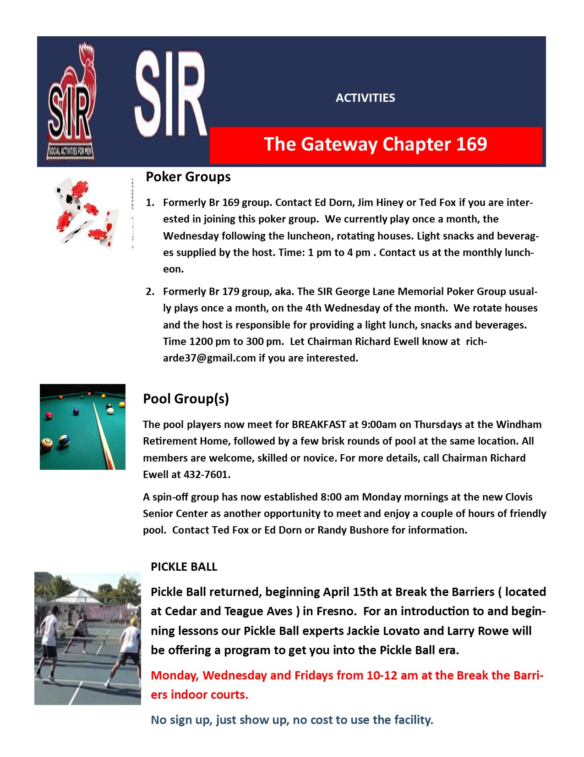

Larry Zander

ACTIVITIES
Golf:
NCGA Dues: Your NCGA dues are now due. If you are renewing, the cost is $45 payable to Sirs Golf 169. You can bring a check to the luncheon or mail it to Ed Dorn at 10418 N. Sinclair Cr., Fresno, Ca. 93730
Complete results and the current schedule can be found on the golf web page:
https://sirgcarea29br169.memberplanet.com
June Schedule:
Joe Russo is the host for June
June 6th 8:00 Madera Muni Cha Cha Cha
June 20th 9:00 River Creek (Oakhurst) 2man bb
June 27th 8:00 Dragon Fly 4man 2bb
Note: June 6th is the second leg of the branch championship

Thank You to Brian Ohde for hosting in May

Pool Group(s)
The pool players now meet for BREAKFAST at 9:00am on Thursdays at the Windham Retirement Home, followed by a few brisk rounds of pool at the same location. All members are welcome, skilled or novice. For more details, call Chairman Richard Ewell at 432-7601.
A spin-off group has now established 8:00 am Monday mornings at the new Clovis Senior Center as another opportunity to meet and enjoy a couple of hours of friendly pool. Contact Ted Fox or Ed Dorn or Randy Bushore for information.

Poker Groups
Formerly Br 169 group. Contact Ed Dorn, Jim Hiney or Ted Fox if you are interested in joining this poker group. We currently play once a month, the Wednesday following the luncheon, rotating houses. Light snacks and beverages supplied by the host. Time: 1 pm to 4 pm . Contact us at the monthly luncheon.
Formerly Br 179 group, aka. The SIR George Lane Memorial Poker Group usually plays once a month, on the 4th Wednesday of the month. We rotate houses and the host is responsible for providing a light lunch, snacks and beverages. Time 1200 pm to 300 pm. Let Chairman Richard Ewell know at richarde37@gmail.com if you are interested.

WHEN; TUESDAY, February 11, 2025
WHERE: Pardinis Catering
TIME: 1000 BEC Mtg, 1100 Social Hour, 1200 Lunch
COST: Lunch $25. No Charge to members celebrating their
Birthday in February (Must attend to receive benefit).
Branch Dues: $20.00 are due.
GUEST SPEAKER: Valerie Salcedo, Speaker, Actress, Singer, former Ms Fresno County
MENU: Fish, Chicken or Chef Salad. And if you have
other Dietary requirement, please let your caller
know so that arrangements can be made.

NOVEMBER 2024 TREASURERS REPORT

ACTIVITIES
Golf:

Complete results and the current schedule can be found on the golf web page:
https://sirgcarea29br169.memberplanet.com

June Schedule: Note: There is a Monday scheduled this month
Ken Myers is the host for June
June 4th Tuesday 8:00 Madera Muni Cha Cha Cha
June 17th Monday 8:00 Ridge Creek Lone Ranger
June 25th Tuesday 8:00 Dragon Fly 4man2bb
Thank you to Brian Ohde for hosting in May

Sir State Golf
The State Sir Golf committee has events in June, August, September and October.
For Additional information go to: https://www.golf.sirinc2.org

The Gateway Chapter 169

SIR 169 Executive Board and Committee Chairman

Golf:
Current schedule can be found on the golf web page:
https://sirgcarea29br169.memberplanet.com

February Schedule:
Dan Lindstrom is the host
￼
Thank You, Ken Myers for hosting in January

Sir State Golf: Schedule: https://www.sirinc2.org/golf
If you have not paid your NCGA dues, please do so as soon as possible.

DATE NIGHTS OUT:
Couples’ Nite Out: February 13th
George’s Bar and Grill on North Blackstone Ave. Dinner at 6:00. Contact Ed Dorn or sign up at the February luncheon.

Sirs Diners: 3rd Wednesday February 19th
La Kebrada Restaurant at 9415 Fort Washington Road. Contact Don Laines for more information.

Date-Nite: 3rd Wednesday February 19th
I made a reservation for February 19th at 4:30 at Yosemite Ranch Restaurant. The restaurant is located at 1520 East Champlain Drive (northeast corner of Champlain and Shepherd). Their telephone number is 434-4403. My cell phone is 906-9050.

FEBRUARY 2025

SIRS BRANCH 169 E-BOARD MEETING
Date: January 14, 2025 at Pardini’s. Time: Social Hour 11:30-12:00. Lunch 12:00
BIG SIR: John Eleazarian called the meeting to order at 10:00 AM.
ATTENDING: Manny Contino, Duane Evans, Jim Hiney, Bernie Hollenbeck, Luis Rodriquez, Bob Large, Ted Fox, Nick Lopez, Ernie Sopp, Rodger Steward, and Roy Grijalva.
MINUTES OF THE PREVIOUS MEETING: MSC.
GUESTS TODAY: None
TREASURER REPORT: Nick Lopez reported that for December 2024, Luncheon receipts $3615.00. 50/50 was $155.00. Expenses Pardini’s $3662.56. Bullard Talent PTSA $300.00 Ending Check Book Balance of $8565.06. Petty Cash $100.00. TOTAL CASH AVAILABLE of $8665.06. Nick added that the State dues assessment went down by $4.00.
SECRETARY’S REPORT: MSC- Assistant Secretary Recorder Luis Rodriquez submitted a copy of December 10, 2024 minutes provide by Jim Forden BEC Minutes.
BIG SIR: John Eleazarian provided the 2025 Pardini’s menu to the Secretary Recorder and to Ted Fox. Ernie Sopp reported that the Bullard Talent is booked for December Luncheon. John will ask the club members for an assistant to help Bernie Hollenbeck.
LITTLE SIR REPORT: Little Sir Manny Contino at Paul Loeffler has agreed to be our March 11th Guest Speaker. He also reported that Valerie Salcedo will be here for the February Ladies Day Luncheon in due of Valentines Day.
MEMBERSHIP: Jim Hiney reported that Kevin Jones, Rick Garcia, Jerry Wong, Brian Lee are waiting to be inducted. Rick Garcia and Mark Portillo were inducted today.
TODAY’S LUNCHEON ATTENDANCE: Reported to Pardini’s 100.
MEMBERSHIP: Doug Nowlin and Nick want be placed on inactive list.
PROGRAM OR SPEAKER TODAY: Craig Cooper former California Fish & Game Lieutenant and former Sequoia Safety Council.
OLD BUSINESS: None today
NEW BUSINESS: Rodger Stewart reported on the State BEC Meeting about women being added to SIRs Club to increase membership.
SUNSHINE REPORT: Nothing to add.
ACTIVITIES: Ed Dorn on vacation. Nothing on Golf activities. Jim Hiney reported Couples Night Out will be Namikaze Restaurant, Date Night will be at Western B-B-Q, and DIRs Diners at George Restaurant.
MEETING ADJOURNED AT: 11:08 AM
RESPECTLY SUBMITTED: For vacationing, Jim Forden Secretary,
Luis Rodriquez,
Assistant Secretary Recorder

Beginning Balance $ 8,562.96
Income $ 4,257.00
Expenses $ 2,879.88
Ending Checkbook Bal $ 9,940.08
Petty Cash $ 100.00
Total Balance $ 10,040.08

Treasures report subject to final approval at the February BEC meeting.following months BEC Meeting.

FEBRUARY LUNCHEON, LADIES DAY

BRANCH INFORMATION (cont)

mmmmmmmmmmmmmmmmmmmmmmmmmemmememem MMMMMMMMMMMem Membership

I have frequently been told that members have not been contacted about the upcoming meeting and the menu choices, I have therefore tried my best to assemble a list featuring the current callers(highlighted) and the members they have been assigned to call, (subject to change). Currently we have 139 active members. So if you are not receiving a monthly call, text, email etc. from your caller. Call him. This is very important as Bernie needs an accurate count for the luncheon attendees. Caller phone numbers are on the preceding page.

The Gateway Chapter 169

BIRTHDAYS
RICHARD EWELL ROY GRIJALVA BRIAN OHDE
MICHAEL PANELLA JOE RUSSSO GRANT SHARP

ANNIVERSARIES
MICHAEL AND LISA CARRERA JOE AND CATHY RUSSO
GEORGE AND CAROL FINNEY ROBERT SND TEDDY SAULSBURY
ERNEST AND GRACE REYES WAYNE AND COLEEN SCHWARTZ
RON AD MARCIE SILVA GERALD AND SHIRLEY STOLTENBERG

JANUARY TREASURES REPORT

PICKLE BALL
Pickle Ball returned, beginning April 15th at Break the Barriers ( located at Cedar and Teague Aves ) in Fresno. For an introduction to and beginning lessons our Pickle Ball experts Jackie Lovato and Larry Rowe will be offering a program to get you into the Pickle Ball era.
Monday, Wednesday and Fridays from 10-12 am at the Break the Barriers indoor courts.
No sign up, just show up, no cost to use the facility.

Happy Valentines Day

Branch Website: SIR169.org
State Website: SIRINC.org

See January 2025 Newsletter for a complete listing of all committee chairmen and contact numbers.

The Gateway Chapter 169

The Gateway Chapter 169

The Gateway Chapter 169

The Gateway Chapter 169

The Gateway Chapter 169

Feb 4, Tues | 9:00 | Airways | Cha Cha Cha
Feb 18 Tues | 9:00 | Madera Muni | 4 Man 2bb
Feb 25 Tues | 8:30 | Riverside | Lone Ranger
The Gateway Chapter 169
ACTIVITIES
Golf:
NCGA Dues: Your NCGA dues are now due. If you are renewing, the cost is $45 payable to Sirs Golf 169. You can bring a check to the luncheon or mail it to Ed Dorn at 10418 N. Sinclair Cr., Fresno, Ca. 93730
Complete results and the current schedule can be found on the golf web page:
https://sirgcarea29br169.memberplanet.com
June Schedule:
Joe Russo is the host for June
June 6th 8:00 Madera Muni Cha Cha Cha
June 20th 9:00 River Creek (Oakhurst) 2man bb
June 27th 8:00 Dragon Fly 4man 2bb
Note: June 6th is the second leg of the branch championship

Thank You to Brian Ohde for hosting in May

Pool Group(s)
The pool players now meet for BREAKFAST at 9:00am on Thursdays at the Windham Retirement Home, followed by a few brisk rounds of pool at the same location. All members are welcome, skilled or novice. For more details, call Chairman Richard Ewell at 432-7601.
A spin-off group has now established 8:00 am Monday mornings at the new Clovis Senior Center as another opportunity to meet and enjoy a couple of hours of friendly pool. Contact Ted Fox or Ed Dorn or Randy Bushore for information.

Poker Groups
Formerly Br 169 group. Contact Ed Dorn, Jim Hiney or Ted Fox if you are interested in joining this poker group. We currently play once a month, the Wednesday following the luncheon, rotating houses. Light snacks and beverages supplied by the host. Time: 1 pm to 4 pm . Contact us at the monthly luncheon.
Formerly Br 179 group, aka. The SIR George Lane Memorial Poker Group usually plays once a month, on the 4th Wednesday of the month. We rotate houses and the host is responsible for providing a light lunch, snacks and beverages. Time 1200 pm to 300 pm. Let Chairman Richard Ewell know at richarde37@gmail.com if you are interested.

WHEN; TUESDAY, February 11, 2025
WHERE: Pardinis Catering
TIME: 1000 BEC Mtg, 1100 Social Hour, 1200 Lunch
COST: Lunch $25. No Charge to members celebrating their
Birthday in February (Must attend to receive benefit).
Branch Dues: $20.00 are due.
GUEST SPEAKER: Valerie Salcedo, Speaker, Actress, Singer, former Ms Fresno County
MENU: Fish, Chicken or Chef Salad. And if you have
other Dietary requirement, please let your caller
know so that arrangements can be made.

NOVEMBER 2024 TREASURERS REPORT

ACTIVITIES
Golf:

Complete results and the current schedule can be found on the golf web page:
https://sirgcarea29br169.memberplanet.com

June Schedule: Note: There is a Monday scheduled this month
Ken Myers is the host for June
June 4th Tuesday 8:00 Madera Muni Cha Cha Cha
June 17th Monday 8:00 Ridge Creek Lone Ranger
June 25th Tuesday 8:00 Dragon Fly 4man2bb
Thank you to Brian Ohde for hosting in May

Sir State Golf
The State Sir Golf committee has events in June, August, September and October.
For Additional information go to: https://www.golf.sirinc2.org

The Gateway Chapter 169

SIR 169 Executive Board and Committee Chairman

Golf:
Current schedule can be found on the golf web page:
https://sirgcarea29br169.memberplanet.com

February Schedule:
Dan Lindstrom is the host
￼
Thank You, Ken Myers for hosting in January

Sir State Golf: Schedule: https://www.sirinc2.org/golf
If you have not paid your NCGA dues, please do so as soon as possible.

DATE NIGHTS OUT:
Couples’ Nite Out: February 13th
George’s Bar and Grill on North Blackstone Ave. Dinner at 6:00. Contact Ed Dorn or sign up at the February luncheon.

Sirs Diners: 3rd Wednesday February 19th
La Kebrada Restaurant at 9415 Fort Washington Road. Contact Don Laines for more information.

Date-Nite: 3rd Wednesday February 19th
I made a reservation for February 19th at 4:30 at Yosemite Ranch Restaurant. The restaurant is located at 1520 East Champlain Drive (northeast corner of Champlain and Shepherd). Their telephone number is 434-4403. My cell phone is 906-9050.

FEBRUARY 2025

SIRS BRANCH 169 E-BOARD MEETING
Date: January 14, 2025 at Pardini’s. Time: Social Hour 11:30-12:00. Lunch 12:00
BIG SIR: John Eleazarian called the meeting to order at 10:00 AM.
ATTENDING: Manny Contino, Duane Evans, Jim Hiney, Bernie Hollenbeck, Luis Rodriquez, Bob Large, Ted Fox, Nick Lopez, Ernie Sopp, Rodger Steward, and Roy Grijalva.
MINUTES OF THE PREVIOUS MEETING: MSC.
GUESTS TODAY: None
TREASURER REPORT: Nick Lopez reported that for December 2024, Luncheon receipts $3615.00. 50/50 was $155.00. Expenses Pardini’s $3662.56. Bullard Talent PTSA $300.00 Ending Check Book Balance of $8565.06. Petty Cash $100.00. TOTAL CASH AVAILABLE of $8665.06. Nick added that the State dues assessment went down by $4.00.
SECRETARY’S REPORT: MSC- Assistant Secretary Recorder Luis Rodriquez submitted a copy of December 10, 2024 minutes provide by Jim Forden BEC Minutes.
BIG SIR: John Eleazarian provided the 2025 Pardini’s menu to the Secretary Recorder and to Ted Fox. Ernie Sopp reported that the Bullard Talent is booked for December Luncheon. John will ask the club members for an assistant to help Bernie Hollenbeck.
LITTLE SIR REPORT: Little Sir Manny Contino at Paul Loeffler has agreed to be our March 11th Guest Speaker. He also reported that Valerie Salcedo will be here for the February Ladies Day Luncheon in due of Valentines Day.
MEMBERSHIP: Jim Hiney reported that Kevin Jones, Rick Garcia, Jerry Wong, Brian Lee are waiting to be inducted. Rick Garcia and Mark Portillo were inducted today.
TODAY’S LUNCHEON ATTENDANCE: Reported to Pardini’s 100.
MEMBERSHIP: Doug Nowlin and Nick want be placed on inactive list.
PROGRAM OR SPEAKER TODAY: Craig Cooper former California Fish & Game Lieutenant and former Sequoia Safety Council.
OLD BUSINESS: None today
NEW BUSINESS: Rodger Stewart reported on the State BEC Meeting about women being added to SIRs Club to increase membership.
SUNSHINE REPORT: Nothing to add.
ACTIVITIES: Ed Dorn on vacation. Nothing on Golf activities. Jim Hiney reported Couples Night Out will be Namikaze Restaurant, Date Night will be at Western B-B-Q, and DIRs Diners at George Restaurant.
MEETING ADJOURNED AT: 11:08 AM
RESPECTLY SUBMITTED: For vacationing, Jim Forden Secretary,
Luis Rodriquez,
Assistant Secretary Recorder

Beginning Balance $ 8,562.96
Income $ 4,257.00
Expenses $ 2,879.88
Ending Checkbook Bal $ 9,940.08
Petty Cash $ 100.00
Total Balance $ 10,040.08

Treasures report subject to final approval at the February BEC meeting.following months BEC Meeting.

FEBRUARY LUNCHEON, LADIES DAY

BRANCH INFORMATION (cont)

mmmmmmmmmmmmmmmmmmmmmmmmmemmememem MMMMMMMMMMMem Membership

I have frequently been told that members have not been contacted about the upcoming meeting and the menu choices, I have therefore tried my best to assemble a list featuring the current callers(highlighted) and the members they have been assigned to call, (subject to change). Currently we have 139 active members. So if you are not receiving a monthly call, text, email etc. from your caller. Call him. This is very important as Bernie needs an accurate count for the luncheon attendees. Caller phone numbers are on the preceding page.

The Gateway Chapter 169

BIRTHDAYS
RICHARD EWELL ROY GRIJALVA BRIAN OHDE
MICHAEL PANELLA JOE RUSSSO GRANT SHARP

ANNIVERSARIES
MICHAEL AND LISA CARRERA JOE AND CATHY RUSSO
GEORGE AND CAROL FINNEY ROBERT SND TEDDY SAULSBURY
ERNEST AND GRACE REYES WAYNE AND COLEEN SCHWARTZ
RON AD MARCIE SILVA GERALD AND SHIRLEY STOLTENBERG

JANUARY TREASURES REPORT

PICKLE BALL
Pickle Ball returned, beginning April 15th at Break the Barriers ( located at Cedar and Teague Aves ) in Fresno. For an introduction to and beginning lessons our Pickle Ball experts Jackie Lovato and Larry Rowe will be offering a program to get you into the Pickle Ball era.
Monday, Wednesday and Fridays from 10-12 am at the Break the Barriers indoor courts.
No sign up, just show up, no cost to use the facility.

Happy Valentines Day

Branch Website: SIR169.org
State Website: SIRINC.org

See January 2025 Newsletter for a complete listing of all committee chairmen and contact numbers.

The Gateway Chapter 169

The Gateway Chapter 169

The Gateway Chapter 169

The Gateway Chapter 169

The Gateway Chapter 169

Feb 4, Tues | 9:00 | Airways | Cha Cha Cha
Feb 18 Tues | 9:00 | Madera Muni | 4 Man 2bb
Feb 25 Tues | 8:30 | Riverside | Lone Ranger
The Gateway Chapter 169

